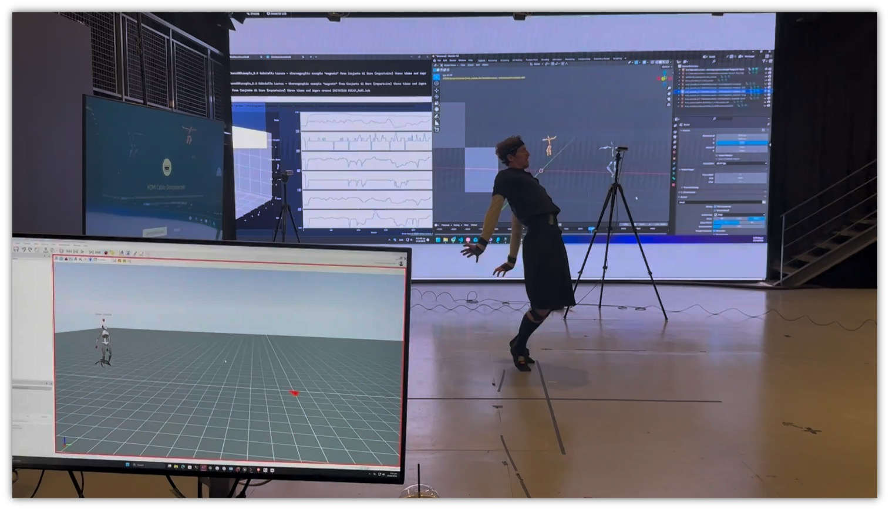
HAMLET
1 caption

Application template

Open call

Trust me, I’m an AI/rtist

Call closes

30th September 2026, 23:59 CEST

Info session

31st July 2026, 10:00-11:30 CEST



Introduction

General instructions for preparing your proposal

Please use this template to prepare your proposal. It is organised to ensure that all important aspects of your planned work are clearly stated. When preparing your proposal please consider the evaluation criteria, as well as the timeline and project phases as defined in the Guide for Applicants.

The structure of this template must be followed when preparing your proposal. Only proposals that successfully address all the required sections will be considered eligible for evaluation. The page limit for full proposals is 7 pages (excluding cover page, additional page for free visuals and references if any). We advise you to consider readability for diverse readers, suggested font size is 11, with 1.5-line spacing, page size A4 standard. There is one additional page at the end of the document for free sketches, artwork, visuals etc. Do not use that page for text, which would extent the requested answers regarding your proposal. Please note that additional pages will not be included in the evaluation.

Submission Deadline: 30 September, 2026 23:59 CEST

Please complete and save/upload document in PDF format. When saving the final document, you may delete this instruction page.

[INSERT PROPOSAL TITLE]

Artistic Practice and Motivation
Briefly introduce your artistic practice and its relation to this open call.

Please address:
- What are your main artistic practices, methods and areas of interest?
- How do you relate to AI in general and in your own practice?
- Have generative AI tools influenced your creative workflow or decision-making processes?
- Why are you interested in participating in Trust Me, I’m an AI/rtist?

Suggested length max 400 words.

Artistic Intervention and Enabler Selection
Please select up to three of the Enabler(s) you wish to engage with and highlight them:
- Enabler #1: Generic Procedural Content Generation Enabler (CERTH, Greece)
- Enabler #2: Data-Driven Cultural Content Adaptation Enabler (CERTH, Greece)
- Enabler #3: Cross-Domain Audience Engagement Analytics Enabler (TAA, UK)
- Enabler #4: Dance Style Analysis and Generation Enabler (CYENS, Cyprus)
- Enabler #5: Immersive Design Integration Enabler for Dance & Theatre (CYENS, Cyprus)
- Enabler #6: Music-to-Movement Translation Enabler (AUTH, Greece)
- Enabler #7: Adaptive Narrative Enabler for Games & Theatre (CAUSA, Austria)

Describe your proposed artistic intervention.
Please address:
- What is the core artistic concept?
- What questions, tensions, opportunities or concerns motivate the project? These may relate to topics such as authorship, labour, embodiment, audience participation, surveillance, bias, sustainability, accessibility, cultural memory, storytelling, identity, agency, creativity or other issues relevant to your practice.
- Why have you chosen this Enabler?
- How do you intend to engage with it?

You may choose to investigate, challenge, reimagine, misuse, collaborate with, expose, perform through, parody, reinterpret or otherwise respond to the selected Enabler. We are interested in artistic investigations rather than technological solutions.

Suggested length max 400 words.

Why does this matter?
Describe why this project matters.

Please address:
- What critical, social, political, environmental or ethical questions does your project explore?
- What new perspectives, discussions or forms of understanding might emerge?
- How might the project engage audiences, communities, cultural institutions, policymakers or industry actors?
- If relevant, how will the project contribute to wider reflection on AI and creativity?

Suggested length max 300 words.

Methodology and Collaboration
Describe how you will develop the project.

Please address:
- What artistic methods, approaches or processes will you use?
- How will research, experimentation and creation be combined?
- How do you plan to collaborate with the technology partner developing the Enabler?
- What kind of exchange, access or support would you need from the partner?

We welcome artistic research, critical making, speculative design, performance, participatory approaches, experimental media practices and other transdisciplinary methods.

Suggested length max 300 words.

Work Plan and Timeline

Describe the main phases of the project and expected milestones.

Period | Activities
Research &
onboarding
Experimentation &
development
Production &
refinement
Public presentation

Budget Overview

Briefly explain how you intend to allocate the residency budget.

Where possible, applicants are encouraged to consider open-source tools and infrastructures.

Category | Cost
Artist fee
Travel & accommodation
Production costs
Material & equipment
Other costs
Total (max. 20.000 EUR)

The residency budget should cover artist fees, travel, accommodation, production and other project-related costs. Applicants are not expected to allocate all categories if not relevant to their proposal.

Portfolio and Supporting Material

Please provide also:
- Visualisation (1 page)
- Portfolio with links to relevant works (max. 10 pages)

